# **MICROSERVICES**

1. Creating Microservices for account and loan. In these hands-on exercises, we will create two microservices for a bank. One microservice for handing accounts and one for handling loans.

Each microservice will be a specific independent Spring RESTful Webservice maven project having it's own pom.xml. The only difference is that, instead of having both account and loan as a single application, it is split into two different applications. These webservices will be a simple service without any backend connectivity. Account Microservice

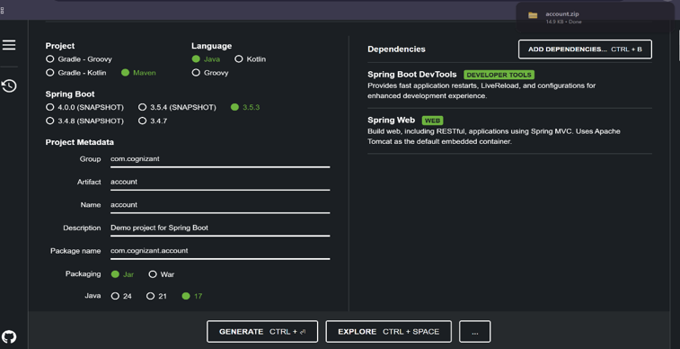

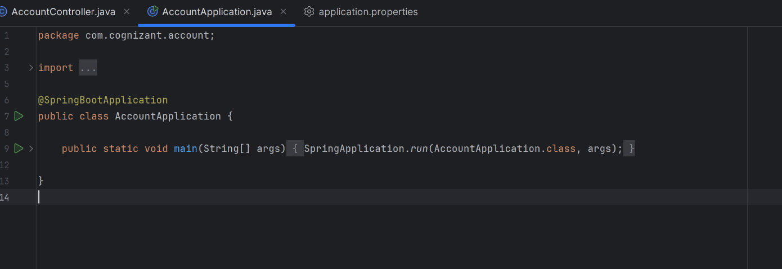

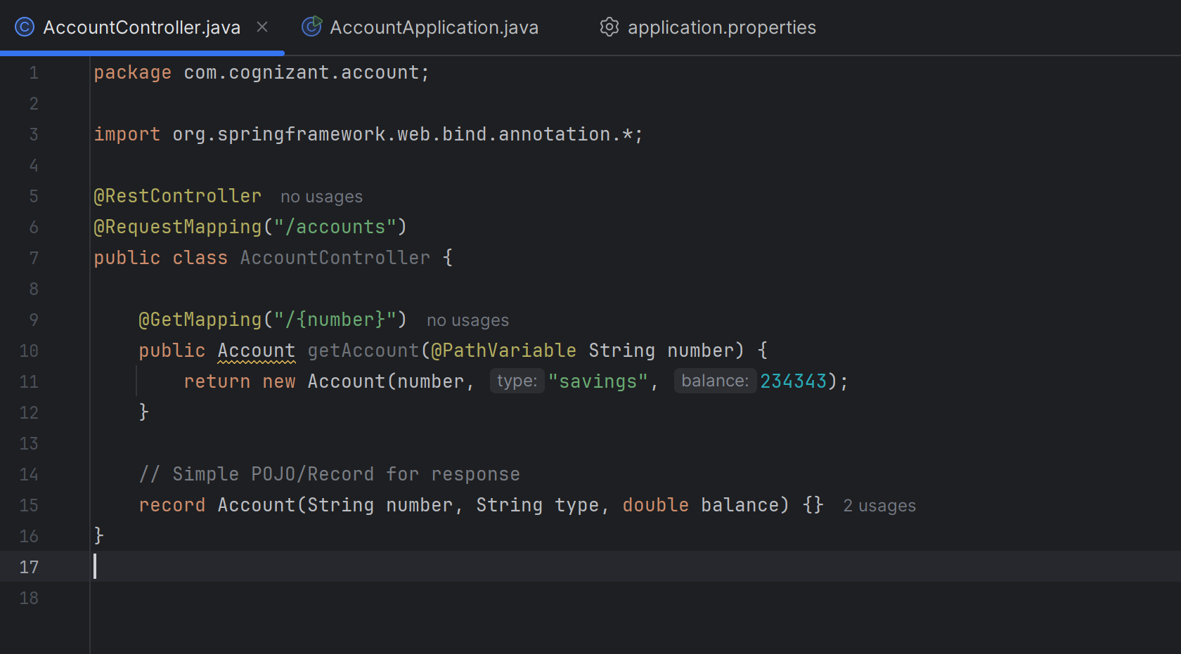

**OUTPUT**

http://localhost:8085/accounts/00987987973432

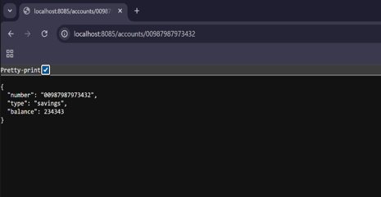

---------------------------

**Loan Microservice**

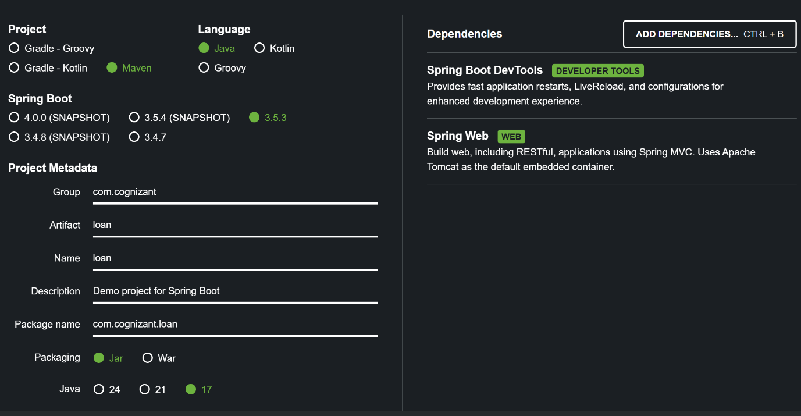

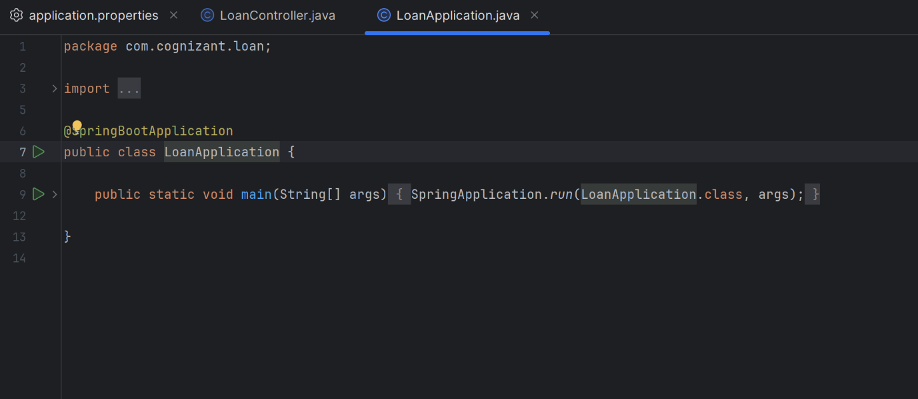

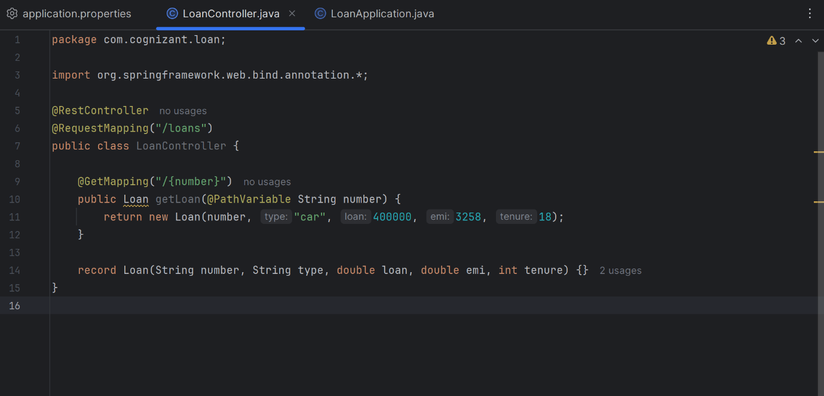

**OUTPUT**

http://localhost:8087/loans/H00987987972342

